***Name: Ali Hassaan Mughal***

***Regn No: 173627***

***Current IP: 10.3.40.113***

***Lab Title:*** *Tracing the path to a destination*

**1.0 Objective of this lab:**

In this lab, we’ll explore several networking tools to trace the path followed by packets to a particular destination.

**2.0 Instructions:**

* Read carefully before starting the lab.
* These exercises are to be done individually.
* You are supposed to provide the answers to the questions listed at the end of this document, paste the screenshots of your working and upload the completed report to your course’s LMS site.
* Avoid plagiarism by copying from the Internet or from your peers. You may refer to source/ text but you must paraphrase the original work.

**Steps for performing this lab:**

1. **Open the command prompt application**
2. **Start up the Wireshark packet sniffer.**
3. **Begin packet capture.**
4. Type “tracert www.usyd.edu.au” (or traceroute) in command prompt and press enter.
5. You can use geoip files uploaded on LMS to find the location of certain ip use following links for help

<https://wiki.wireshark.org/HowToUseGeoIP>

<https://dev.maxmind.com/geoip/legacy/geolite/>

**Now answer the following questions:**

1. What are the IP address of the host [www.usyd.edu.au](http://www.usyd.edu.au) and the IP of your machine?

**My IP:** 10.3.40.113

**Host IP:** 

1. How many hops is the destination host away from your machine?

My machine is 17 hops away from the destination host.

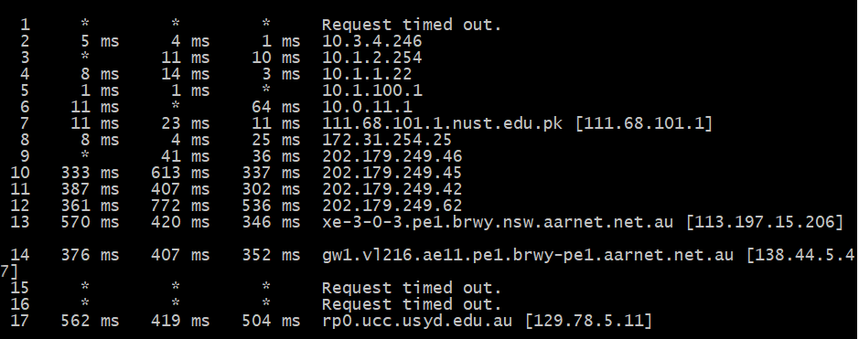

1. How many hops are between your machine and the NUST gateway router?

My machine is 7 hops away from the my machine.



1. How many routers does these packets visit in Pakistan?

I think, It visited 8 routes in Pakistan, including a private ip range which has a very less RTT, i.e. possible from within Pakistan, afterwards the next RTT increases to a big number.



1. Where is the website [www.usyd.edu.au](http://www.usyd.edu.au) hosted (city and country)?



1. How many cities your packets have actually visited? List all these cities along with the name of country in the order these have been visited?

111.68.101.1 – Islamabad Pakistan.

172.31.254.25 – Private Router.

202.179.249.46 – China Beijing.

202.179.249.45 – China Beijing.

202.179.249.42 – China Beijing.

202.179.249.62 – China Beijing.







1. Comment if you observe any abnormal/wayward path followed by the traffic from your machine to the destination (It may be useful to roughly draw the path followed by the traffic on a map).

I think the abnormal path way is that it first goes to one end of china, and then to Australia covering a longer distance, than it is from Pakistan to Australia directly.

1. Does the generated traffic always follow the same path to this destination?

Yes, it does in my two tries and one of my friend’s followed the same path to the destination.

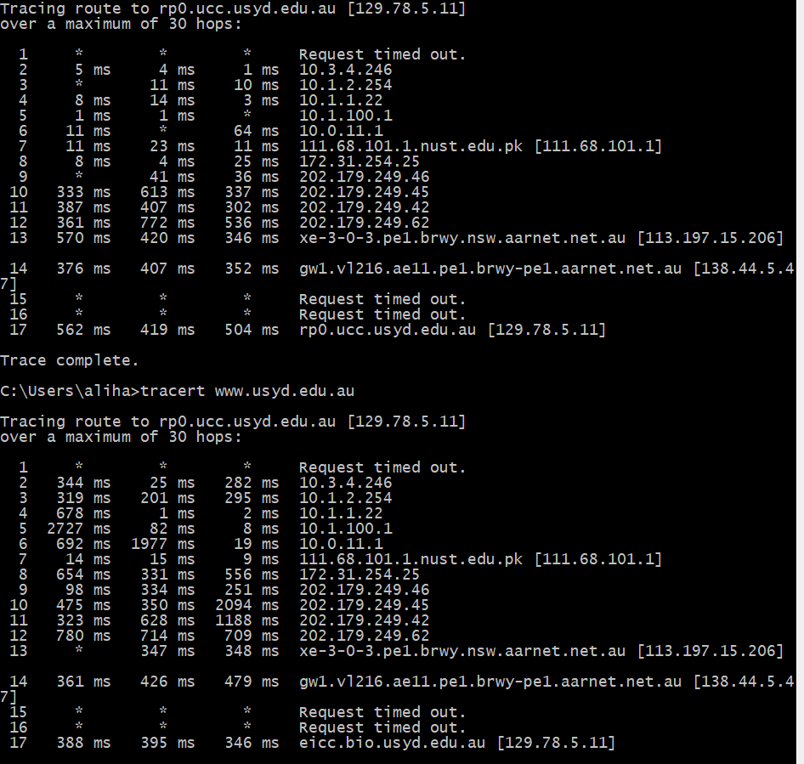

1. How many routers in the path are working in “safe mode” (not replying to any query)?

There are 3 routers in the path which did not respond to any of the query. Hence 3 routers are in safe mode.

1. Which hop is the longest in the path to the destination?

The longest hop was from Pakistan to china, Beijing i.e. from 9 to 10, as the RTT difference is the longest.

